Lecture No.23 PARASITOLOGY DR.Raad H.H
Phylum Parabasalia
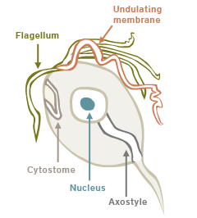
flagellates includes 2 orders ; Trichomonadida (e.g.Trichomonas) and Rhizomastigida ( e.g. Histomonas)
- ORDER: Trichomonadida

Family Trichomonadidae
- 1 karyomastigonts (uninucleate)
- Variable number of flagella , 0 – 6 , associated with karyomastigont ; one flagellum often recurrent and associated as undulating membrane .
  - i.e. Tritrichomonas (3 anterior flagella plus 1 recurved flagellum) .
  - i.e. Trichomonas (4 anterior flagella plus 1 recurved flagellum) .
  - i.e. Pentatritrichomonas ( 5 anterior flagella plus 1 recurved flagellum) .
- Mitochondria absent; parabasal body (Golgi) presesnt
- 1 axostyle
- True cysts rarely formed
- Trophozoites undergo longitudinal binary fission in the intestinal tract; intestinal species can round up and resist passage through stomach
- Urogenital species known to release proteases, dissolve epithelium, and utilize digested products
- Monoxenous.
- Enteric flagellates.
- Oral or venereal transmission.
- Representative genera :

Genus Trichomonas
Trichomonas foetus
(it is also called Tritrichomonas foetus ) ; 3 anterior flagella plus 1 recurved flagellum ; infects urogenital tract of cattle; may cause endometritis , Pyometras and abortion; Disease called Bovine trichomoniasis cause abortion and death of fetus in 1st. semester of pregnancy , recovered cattle acquire self immunity to prevent next abortions; in bulls reproduce in preputal cavity may cause seminal vesicle infection lead to sterility and remain as carrier ; prevention by routine venereal exam. And discard infected bulls ; using artificial insemination by using freezing semen in order to kill parasites. Some evidence suggests that this species also infects the intestinal tract of felids and may cause diarrhea. Recent evidence has also shown Tritrichomonas suis (intestine of swine) to be a synonym.

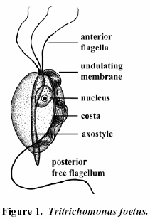

Trichomonas gallinae
(4 anterior flagella undulating membrane only reach 1/3 of the body , the recurved flagellum absent ; infects upper GI tract ( mouth , crop , gizzard of chickens, turkeys, pidgeons, and numerous other birds; old ages as carrier, it can kill young ages birds due to causing glositis , pharyngitis and called chankers similar to fowl pox ) .

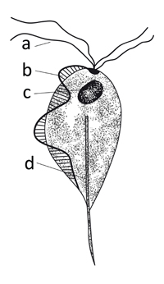
Trichomonas gallinae

Trichomonas gallinarum (4- 5 anterior flagella plus 1 recurved flagellum also called (Tetratrichomonas gallinarum ) ; infects cecum in turkey and liver in fowl cusing enterohepatitis ).
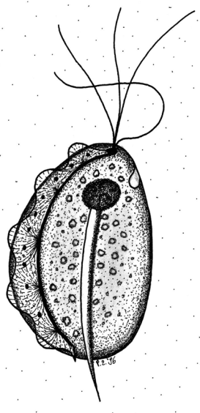
Tetratrichomonas gallinarum

Trichomonas tenax (mouth of humans) .
Trichomonas hominis (man intestine , 4 flagella).

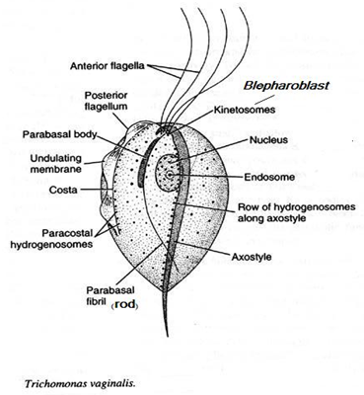
Trichomonas vaginalis (urogenital tract of humans; may cause erosion of urogenital epithelium) .

Family Monocercomonadidae
Genus Monocercomonas { Monocercomonadidae }
A genus of protozoa of the family Monocercomonadidae. No pathogenic effect is associated with the following notable species: M. caviae, M. minuta, M. pistillum (guinea pig), M. cuniculi (rabbit), M. gallinarum (chicken), all in ceca, and M. ruminantium (cattle rumen).
Monocercomonas sp. is a flagellate protozoan showed three anterior flagella, the recurrent flagellum, the axostyle, and the absence of undulating membrane.

- Order Rhizomastigida
Family Mastigaamoebidae
Histomonas meleagridis
- In gallinaceous birds
- Pleomorphic (also called Amoeboflagellates ) ; can exist in dimorphic forms, amoeboid and flagellated. Within the tissue it is present as an amoeboid protozoan, while in the lumen or free in the contents of cecum it lives as an elongated flagellated form. amoeboid form with single flagellum in caecum (however, 4 flagella) ; parabasal body" v" shape.
- Amoeboid form can be invasive; erodes mucosa
- Transmitted in eggs of Heterakis gallinarum
- Turkeys the most susceptible; 3-12 weeks of age; ; enterohepatitis , ulcerations in caecum , perforation of intestine , carried to liver and may cause hepatic abcesses ; disease called blackhead disease of turkeys ( it is so called to cyanotic colour of the head and wattles due to chronic venous congestion ; death (need bacterial secondary infection as Escherichia coli or Clostridium perfringens as well; no bacteria then no pathology)

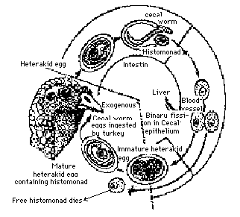
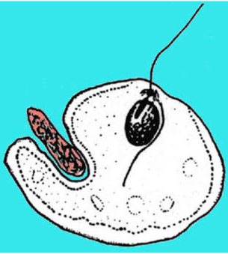

- Diagnosis of Trichomoniasis
      - Bovine trichomoniasis : vaginal biopsy culture and stain by Giemsa.
      - Fowl trichomoniasis :oral and liver biopsy.
- Metronidazol drug of choice ; using antiseptics as Acriflavine .

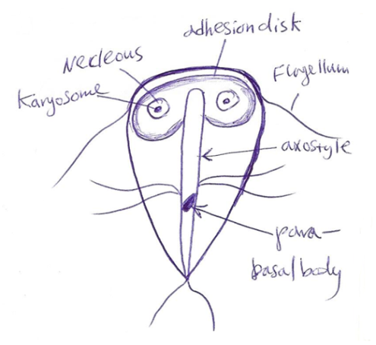
Phylum Maetamonada
ORDER: Diplomonadida
- 2 karyomastigonts (binucleate) .
- 8 flagella total .
- Bilaterally symmetrical shape.
- Mitochondria absent; Golgi absent.
- Free-living or entero - parasitic .
- Common genera include Giardia, Hexamita .
Giardia intestinalis (syns. Giardia duodenalis, Giardia lamblia)
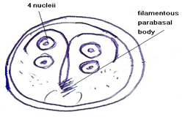
  - tear drop-shaped trophozoites with ventral adhesive disc (NOT a "sucking" disc), 8 flagella, and binucleate.
  - about 80% of the trophozoites possess one or more median bodies, poorly defined microtubule-containing structure(s) that tend to be claw-shaped in this species.
  - ellipsoidal cysts with 4 nuclei when mature.
  - Life-cycle :
    - quadrinucleate cysts ingested.
    - excyst; trophozoites complete division; attach to mucosa of small intestine with ventral adhesive disc .
    - divide by longitudinal binary fission.
    - some produce cysts (2 nuclei) .
    - nuclei and flagella in cyst divide; cytoplasm of trophozoite becomes arrested in middle of division .
    - in a wide variety of medium-large sized mammalian hosts ..
  - Pathology : may include diarrhea, weight loss, abdominal pain; in humans, periodic (cyclic) passage of cysts in feces .
  - Giardia intestinalis is divided into different groups based on rRNA sequences, although groupings and taxonomy is changing rapidly from year to year
    - Human isolates can be typed into 2 different genotypes (group 1 or group 2).
    - Other animals may also harbor these genotypes, however Most Dog isolates can be typed into 2 different genotypes (group 3 and group 4). Other animals rarely share these genotypes. However, dogs sometimes can be found to be passing group 1 or group 2 cysts.
    - Cats can be found to be passing group 1 cysts .
    - group 1 is more evolutionarily divergent; groups 2, 3, and 4 are more closely related.
    - this grouping system should be considered temporary and will certainly change very shortly .
  - other Giardia spp. :
    - Giarida muris in rodents (oval-shaped median bodies).
    - Giarida canis in dogs
    - Giarida cati in cat
    - Giardia bovis
    - Giardia caprae
    - Giardia equi
    - probably many other species in mammals and birds; many other named species but status of each of these requires further studies.
Hexamita spironucleus (syn. Spironucleus meleagridis)
  - in turkey, quail, pheasant, duck, etc.
  - trophozoites binucleate, with 8 flagella; ventral adhesive disk absent .
  - trophozoites undergo binary fission in intestine; cysts passed in feces
  - pathology includes diarrhea, catarrhal enteritis , weight loss , ruffled feathers , death mostly in young age ( 8weeks ).
  - similar species
    - Octomitus intestinalis (rodents)
    - Spironucleus columbae (pigeons)
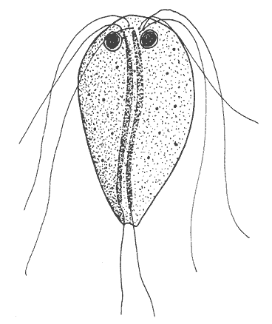
    - Spironucleus muris (rodents)

Sub Phylum Sarcodina

"Amoebae "
- Organisms with pseudopodia ; Pleomorphic .
- asexual reproduction by fission
- most amoebae free-living and marine; few parasitic
Amoebozoa (or Rhizopoda)
    - move by pseudopodia
    - The class Lobosea contains the only parasitic members :
      - pseudopodia lobose or filariform and produced by distinct hyaline lobe; uninucleate
      - 2 groups of importance here
        - Order: Amoebida :
(no flagellate stages) (e.g. Acanthamoeba, Endamoeba, Endolimax, Entamoeba, Hartmannella)
        - Order: Schizopyrenida:
(body monopodal cylinder, usually moving by eruptive, hyaline bulges; most with temporary flagellate stages) (e.g. Balamuthia, Naegleria)
Family Endamoebidae
Genus Entamoeba "intestinal amoebae"
- 4 distinct groups or complexes recognized
- Entamoeba histolytica group
      - small, centrally located endosome
      - cysts with 4 nuclei
      - most pathogens seem to be in this group, and these species can ulcerate the gut wall and abcess nonintestinal sites
      - representative species
        - Entamoeba dispar (intestine of primates; nonpathogenic)
        - Entamoeba equi (intestine of horses)
        - Entamoeba hartmanni (intestine of primates; non pathogenic)
        - Entamoeba histolytica (intestine of primates, canids, swine; potentially pathogenic)
- Entamoeba coli group
      - eccentric endosome
      - cysts with 8-more nuclei
      - may cause diarrhea, but most species noninvasive
      - representative species
        - Entamoeba coli (intestine of primates, canids, swine)
        - Entamoeba cuniculi (intestine of rabbits)
        - Entamoeba muris (intestine of rodents)
        - Entamoeba wenyoni (intestine of goats)
- Entamoeba bovis group
      - endosome varies in size
      - cysts with 1-2 nuclei
      - some species cause diarrhea; however, most noninvasive
      - representative species
        - Entamoeba bovis (intestine of bovids)
        - Entamoeba ovis (intestine of sheep, goats)
- Entamoeba gingivalis group
      - small, central endosome
      - no cysts produced
      - all species oral
      - representative species
        - Entamoeba equibuccalis (horses)
        - Entamoeba gingivalis (primates, canids, felids)

